"We've Entered a 'Fullness of Time!'"

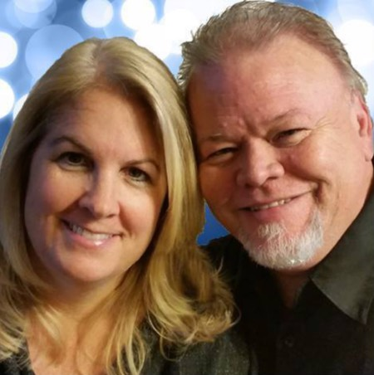

Danny Steyne, Andover, CT
"What I Want Isn't Here Yet"
I had just travelled up the freeway toward my new exit as I moved to New England on October 2, 2012. As I passed many angels along the route, I noticed a huge one at the end of the procession ... one who I had met several times before, but one who had never spoken to me. There was a bluish haze all over him, and I noted the fact that he was evidently an archangel. He spoke, "Are you ready to do this?" As I fumbled for words I said, "Let's do this thing!" I then turned my words to the Lord. "What do You want me to do?"
"What I want isn't here yet," He responded. Not satisfied with the answer, I asked again, "What do You want me to do?" He responded, "I want you to redefine church." I then had a vision of a cruise ship, and He indicated that the difficulty of this assignment was going to be like redefining a cruise ship to people who already had what a cruise ship was etched in their minds. Realizing that I still really didn't know what that would mean, I asked Him a third time, "What do You want me to do?" He responded, "I want you to take over!" The words landed in my spirit with a shock. I said, "Lord, that sounds very bold ... very arrogant ... what do You mean?" I didn't hear any response.

"Pleroma"
Pleroma: When all of history meets all of destiny in an epoch of time, unrestrained by conditions, circumstances, or events. The fullness of time.
God began teaching me about "pleroma," a word used in the Word a number of times, but always having to do with "fullness of time." It was a "fullness of time" that He was looking for, to reveal the glory of His presence on His Bride and a powerful move of God around the earth. There have been "fullness of times" in the past. It was a four-hundred-year wait for the most significant "fullness of time" that the earth would ever experience. The exasperation and frustration had mounted to a crescendo before Jesus broke the silence of those four-hundred, silent years. The earth was "ready" to receive Jesus. (Photo via Unsplash)
As I began researching I found out that, in fact, the word pleroma speaks of a ship, fully outfitted for deep sea voyages with all supplies, sailors, soldiers, and sails ready. I found it very interesting that in Ephesians 4:12, the phrase "equipping the saints" also means "mending the nets." It seems to me that God is telling us our ship is about to come in, and we are about to embark on that ship!
It would be the spring of 2018 where the Lord would finally begin revealing what it was He wanted. He again showed me the cruise ship. My frustration was complete. I needed to look at this cruise ship differently. I heard, "You can only redefine something if you look at original intent!" I had to go back to the beginning and that was where I finally saw what it was He wanted.
"Original Intent"
He showed me that the "original intent" of a ship was for fishing. Jesus would speak directly to fisherman about what was going to transpire in their lives if they followed Him. They had to be fishermen after men! The fish wouldn't be in the water, but in the glory of the Lord that covers the earth as the waters cover the sea. The demonstration of His boat was taking them from fishing holes to schools of fish where the harvest would be plenty!

He also showed me that the "original intent" of a ship was for transporting people from one location to another. Ships aren't meant to be lived on, although some are used for this, they are intended to be transportations. So, too, the Church is intended to transport people from one location to another, not keeping them on board, not hoarding people as if the presence of people on a boat made it a success story.
There is an entry time and an exit time. People were intended to be equipped, trained, and released to continue walking in the way of the Lord.
Thirdly, He showed me that the "original intent" of a ship was to take supplies from places where there was an abundance, to places where there was lack. The early Church functioned in this profoundly. They actually had seasons where no one was in need! History records these events through people like Josephus. The early Church took very seriously the fact that provision was intended to be released to others. Paul, writing to the Ephesians says, "Work so that you can help those in need!" (Ephesians 4:28 paraphrased).
Over and over in the New Testament, from both Paul and the writer to Hebrews and the teaching of Jesus, we learn that we must look out for others' needs, we must bear each other's burdens. In a play on words we find that "every joint supplies" (Ephesians 4:16). We should be supplying to the Body, not simply taking from it.

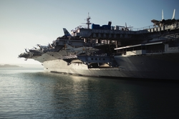
Finally, He then showed me that the "original intent" of a ship was for transporting warriors and weapons to places of battle. The Church is a war machine. We have not been called to simply and passively wait for the battle to come to our doorstep, but instead to fulfill what it was that Jesus gave us to fulfill. We are to invade. We are to "take over" regions and nations with His presence. We are to bring light into darkness and penetrate into the most difficult places. The weapons we fight with are not carnal; they are might to pulling down strongholds (see 2 Corinthians 10:3-5). (Photo via Unsplash)
The "Redefining Process"
The Church is going through a profound "redefining process." Most of those who have been involved in ministry more than a decade are recognizing that what once worked, isn't working anymore. We can't simply have our meetings, do the same thing over and over again, and think it's going to produce the fruit that Jesus talked about.
I believe that as we enter this pleroma time, this "fullness of time," those who have been longing for a "real" move of God and not a "hyped" move of God are going to see it. The Body is about to undergo transformation in the most dramatic way. It won't be the boxes we build and decorate that will evidence God. It won't be the bands and the personalities that dominate. It won't be the few who can demonstrate and the fewer who can legislate the direction of the Church. The evidence will be seen everywhere by people everywhere, in ways that look like a lifestyle and not a program or an event.
Pleroma is all about getting on the boat. It's gonna take you somewhere, it's gonna equip you to do something, it's gonna change your heart to pour into others, and it's gonna release you to release others into destiny intended for you and them from the foundations of the earth.
The Church that Jesus is building is founded in revelation not bricks. It's revealing that the evidence of the King and His Kingdom actually looks like something that changes nations and neighbors. It brings freedom to disciples and the demonized. It brings salvation to the least and the greatest. The Church is a people, a verb, a move that can never be housed in a place but can be perpetuated by a people who have found "original intent."

Danny Steyne
Mountain Of Worship

